Matter: Matter is anything that occupies space(volume) and has mass.
Note: Light or energy is not an example of matter.

States of matter: The three common phases (or states) of matter are gases, liquids, and solids.
Matter is composed of particles, which are constantly in motion. This theory is called the Kinetic Molecular Theory

Comparison of Solids, Liquids, and gases


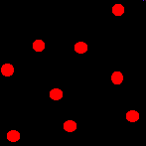

Microscopic view of solids, liquids, gasses

Any property of solids, liquids & gases can be explained by using at least 2 reasons from the table below:
- Based upon the movement of Particles or Kinetic Energy ( it has freedom of movement and speed)
- Based upon the distance between particles ( attraction between particles/BOND)
- Based upon particle arrangement ( orderly/not)

 | Solid | Liquid | gas
( space b/w particles) | strong bond | weaker bond than solids | no bond
Arrangement | orderly | random | random
Movement  Kinetic Energy | Vibrating/  No Kinetic Energy | sliding past each other/  Moderate K.E | particle is randomly moving/  High K.E

 | Shape | Volume | Compressibility | Density | Thermal expansion
Solids | Definite shape | Definite volume | Not compressible | Highest for solids | Slight thermal expansion
liquids | Indefinite shape | Definite volume | slight to low compressiblity | Less than solids | Slight thermal expansion
Gases | Indefinite shape | Indefinite volume | highly compressible | Least for gases | Undergoes thermal expansion

Some Characteristics of Gases, Liquids and Solids and the Microscopic Explanation for the Behavior
gas | liquid | solid
assumes the shape and volume of its container  particles can move past one another | assumes the shape of the part of the container which it occupies  particles can move/slide past one another | retains a fixed volume and shape  rigid - particles locked into place
compressible  lots of free space between particles | not easily compressible  little free space between particles | not easily compressible  little free space between particles
flows easily  particles can move past one another | flows easily  particles can move/slide past one another | does not flow easily  rigid - particles cannot move/slide past one another

Physical and Chemical Properties of Matter
Physical property: A property of matter that can be observed without causing change in the composition of the substance.
Example: color, odor, density, luster, temperature, Volume, Mass, Conductivity, malleability, solubility,
Chemical property: A property of matter that indicates how a substance reacts in the presence of another substance, and it will always result in a change in composition. Example: react, tarnish, explode, corrode, flammable, acidic, basic, neutralize, combustible, decompose, toxic

Physical properties can be extensive or intensive.
Extensive properties vary with the amount of the substance and include mass, weight, a, length, volume.
Intensive properties, in contrast, do not depend on the amount of the substance; they include density, Odor, Malleable, color, melting point, boiling point, electrical conductivity, and physical state at a given temperature.
Note: Intensive properties are used to identify a substance,

Physical and Chemical Changes of Matter
Physical Change: A change of state or appearance ( shape, size)without change in chemical composition

Example: phase changes (Melting, boiling freezing etc), dissolving, breaking, tearing
Phase Changes:
- Melting : Solid to Liq
- Evaporation: Liq to Gas
- Sublimation: Solid to gas

- Freezing: Liq to solid
- Condensation: Gas To liq
- Deposition: Gas to solid

Phase change diagram
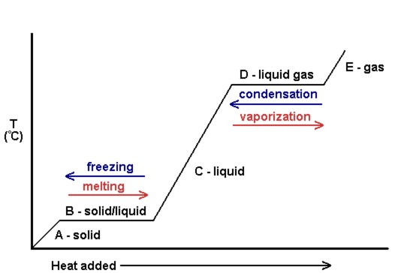

Heating curves show how the temperature changes as a substance is heated up.
Section A, C & E: In all these sections, added heat energy is used to increase the speed in turn the kinetic energy of the particles, which causes an increase in temperature. Average K.E and temp are directly proportional. Therefore, the Average kinetic energy increases with temperature. The distance or the attraction between the particles is not changing in this section because there is only one state of matter.
Evidence: Slopping up
Sections B and Section D: At all the Plateaus, Phase Change happens and during this time temp remains constant because the heat energy absorbed is used for the rearrangement of particles or is being used to break the bonds so the material can undergo transition from one state of matter into another. Since the distance between the particles is changing that means energy stored in the chemical bonds is changing and as a result, potential energy is changing. Since the energy absorbed is not used to speed up the particles, the average KE does not change. Average K.E and temp are directly proportional. Therefore, the Average kinetic energy and temperature remain constant.
Evidence: Plateaus
Remember the 3 Ps. Plateau, Phase Change, and Potential Energy Change.

Cooling Curves
Cooling curves show how the temperature changes as a substance is cooled down. Just like heating curves, cooling curves have horizontal flat parts where the state changes from gas to liquid, or from liquid to solid. These are mirror images of the heating curve but during phase change, the bonds are formed and the energy released is used for the rearrangement of the particles during phase change and that is why the temperature remains constant bcause particle move at the same speed during phase change and based on KMT kinetic energy is directly proportional to temperature.
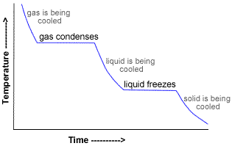

Potential Energy: Energy: energy of position It is the average energy that holds the particles together or potential energy is the stored energy in a chemical bond. It changes when bonds are broken or formed
Kinetic Energy: is the energy due to movement. The average kinetic energy is equal to the temperature of a given substance

Chemical Change; A change that is accompanied by a change in composition or in which a new substance is formed..Example: Rusting, digestion burning, neutralization

Observation or Indicators or Evidence Reason
Fizzing, Bubbling, Smoke, Odor | new substance is formed in the state of gas
Precipitate formation | the new substance is formed in the state of a solid
Temperature Change | This is an indicator that is part of all chemical reactions
Color Change | The new substance is formed in S, L or G
Production of light and sound | Energy change can be observed in so many different forms during a chemical change

Energy Changes in Physical or Chemical Changes
Endothermic Change:
Thermal decomposition is a good example of an endothermic change. Breaking down of Calcium Carbonate to calcium oxide and carbon dioxide
CaCO₃→ CaO + CO₂
- A change in which heat energy is absorbed, (the reaction vessel will be colder because energy is absorbed for some process, like the breaking of chemical bonds )
- Energy flows from the surroundings into the system
- Products will be higher in energy compared to the reactants
( Particles are going to move faster during phase change)

- ΔH = Total energy in products - total energy reactants = positive value because the reaction is gaining heat energy.
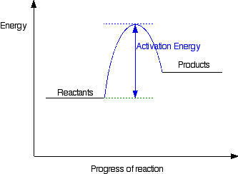

Examples of physical changes which are endothermic melting, boiling, and sublimation

Exothermic change:
Example: All combustion reactions for example CH₄ + O₂→ CO₂ + H₂0
A change in which heat energy is released( reaction vessel will be warmer and usually energy is released when bonds are formed)
Energy is flowing from the system into the surrounding
Products will have less energy compared to the reactants
Δ H = Total energy in products - total energy reactants = negative value because the products have less energy compared to the reactants.

Examples of physical Changes that are exothermic are: deposition, condensation, freezing
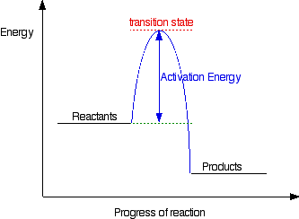

Note: Delta H is the Enthalpy change is the energy difference between the products and the reactants.

Four Classifications of Matter
Microscopic View
- Element. Elements are pure substances that are made up of only one kind of atom. Atoms are the building blocks that have all the characteristic properties of an element. Seven elements exist as diatomic molecules. They are Hydrogen, Oxygen, Nitrogen ,fluorine, bromine ,chlorine &Iodine. (HBrONClIF) |  | diatomic molecule of an element
- Compound: Compounds are pure substances that are made up of only one type of molecule. A molecule is formed by the chemical combination of 2 or more elements and it is the smallest unit of a compound that has all the characteristic properties of the compound. Compounds can be broken to simple substances by chemical means. Example: CO₂, H₂O, H₂O₂ | Molecule of a compound
- Homogeneous Mixture(Solutions): Mixtures that have a similar appearance and properties throughout. They are not pure substances. They can be separated by physical means. Example: aqueous solution of NaCl, air, Alloy(18 carat gold,bronze, brass, steel)  - Heterogeneous Mixture: are mixture that does not have a similar appearance and properties throughout. They are not pure substances. They can be separated by physical means. Example: Muddy water, Chocolate chip cookies, blood | Mixture of pure substances

Separation of Mixtures: Components of a mixture can be separated by various physical processes based on the difference in their physical properties.
Separating a Mixture containing two solids
- Magnetic Separation: one of the components should be magnetic ( Iron).
Magnetic property
- A component is one in which one of the components dissolves in a solvent. Salt and sugar dissolve in water, and sugar dissolves in alcohol. The difference in solubility
- Sublimation: This can be used to separate Iodine from a heterogeneous mixture. The difference in melting point
- Hand Picking or Mechanical separation: This is used to separate when the components in the mixture can be separated based on color, size, or shape.
Separating Mixtures containing a solid and a liquid
- DecantingDecantation is the process of separation of liquid from solid or immiscible (non-mixing) liquids, by letting it rest. So once all the solid particles settle and the liquid layer at the top can be poured out without disturbing the solid layer.
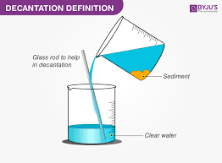
- Filtration: Uses filter paper to separate the solid from the liquid. Used for heterogeneous mixtures based on the size of particles. The substance that is left in the filter paper is called residue and the substance that is in the beaker is called filtrate
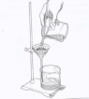
- Distillation:A process of separating a homogeneous solution of closely related compounds based on their large differences in boiling points. In the process, a mixture is heated and the component with the lowest boiling point is driven from the mixture as a vapor or gas. This vapor then condenses on the inside of a condensing tube and the purified liquid with the lowest boiling point drips out the far end of the condensing tube. The component of the mixture with the much higher boiling point remains as a liquid in the round bottom flask.
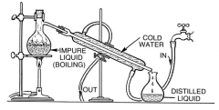( distillate)

- Evaporation – separates a solid from a liquid in which it is dissolved. The disadvantage is that you will lose the liquid component on separation. The difference in boiling point is the physical property that is used for separating this mixture. Example to separate salt from salt water. Water will evaporate away living the salt in the evaporating dish.
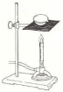
- Centrifuge – separates a solid from a liquid in which it is not dissolved by spinning it at a very high speed (possibly a precipitate, separating cream from milk, separating blood cells in the blood).
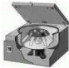
- Chromatography: A technique for separating the components of a mixture between two phases, namely: a stationary Phase ( Paper) and a mobile phase ( Water or alcohol.) The components in the mixture get separated based on the solubility and as a result, it gets separated based on the distance it travels with the solvent. More soluble means it travels with the solvent for a longer distance. The distance traveled by a component in a mixture is going to be constant and can be identified based on the distance traveled with the solvent.
Used for separating components in a dye, ink, or urine or to test for trace amounts of drugs in urine, test for food poisoning, or test for purity in samples in pharmaceutical companies.
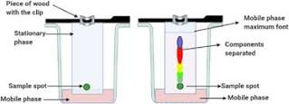
- Crystallization is used to obtain a pure substance from an impure mixture. Another important application of crystallization is its use to obtain pure salt from seawater.
- 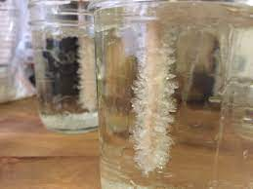
Separating Mixtures containing two liquids
- Separating Funnel
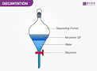
A separatory funnel is used to separate immiscible liquids based on density. When two immiscible liquids are placed in a separatory funnel, two layers are seen, and you can let the bottom layer flow out until it reaches the separation layer.
Laws of Chemical Combination
- Law of Conservation of Mass: Matter can neither be created nor destroyed or total mass of the reactants is equal to the total mass of the products.
Total mass of reactants = Total mass of products
The END



